Myrtle Beach Golf Trip March 2010
We are preparing for our eighth annual “Kick off the golf season” trip to Myrtle Beach. As always, we will only be playing top tier courses, including some of the Top 100 Courses in the U.S. open to the public. The trip will again be four days/three nights, from March 6 to March 9, 2010. We will be booking six rounds as described below. You need not play all six rounds. Price adjustments will be made for those playing less than six rounds. However, you must make the decision when you book, not when you arrive in MB.
LODGING:

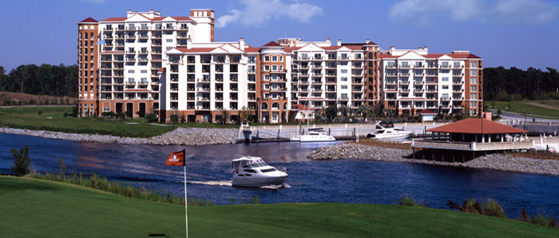

The Premier Choice Of Myrtle Beach Hotels And Resorts (David Paris’ boat shown above)
Every spacious guest room and suite at the Marina Inn is an invitation to immerse yourself in privacy and luxury. Distinctive furnishings of a European-acquired style (as requested by Tony Plesner) suggest fascinating stories of lifetime travels. Subtle colors, rich fabrics and sumptuous linens surround you in utmost comfort. And every thoughtful convenience and amenity is within reach, including:
- Large, luxuriously appointed bathrooms with separate showers
- Plush cotton bath robes
- 300 thread count imported cotton bed linens
- European duvet bedcovers
- Evening turn-down service
- CD and DVD players
- High speed internet access
- Dual phone lines and voicemail
- In-room safe
- Two, three and four bedroom suites are available
http://www.marinainnatgrandedunes.com/index.aspx

Grand Golf On Our Two Magnificent Myrtle Beach Golf Courses
For those who love golf, Grande Dunes is where the game reigns supreme. One of the world's most revered and experienced design teams have created a fantastic South Carolina golf course, boasting unparalleled grandeur and intrigue. Discover rolling green fairways and picturesque views from every hole of the Grande Dunes Resort Club. Exercise your handicap on our two Myrtle Beach golf courses.

- Grande Dunes Resort Club -
- Created by Roger Rulewich, offering a dramatic design featuring seven holes that play along the Intracoastal Waterway. With its numerous elevation changes, wide Bermuda fairways, generous bent grass greens, and more than 34 acres of freshwater lakes, this course sets a new standard for world-class play. Over 7,600 yards from tip to tip make this one of the longest courses on the East Coast. Pictured below is one of the best par 3’s in Myrtle Beach… #14 at Grand Dunes Resort Course. Here is a link to an old article about Grande Dunes: http://www.myrtlebeachgolf.com/departments/coursereviews/grande-dunes-country-club/

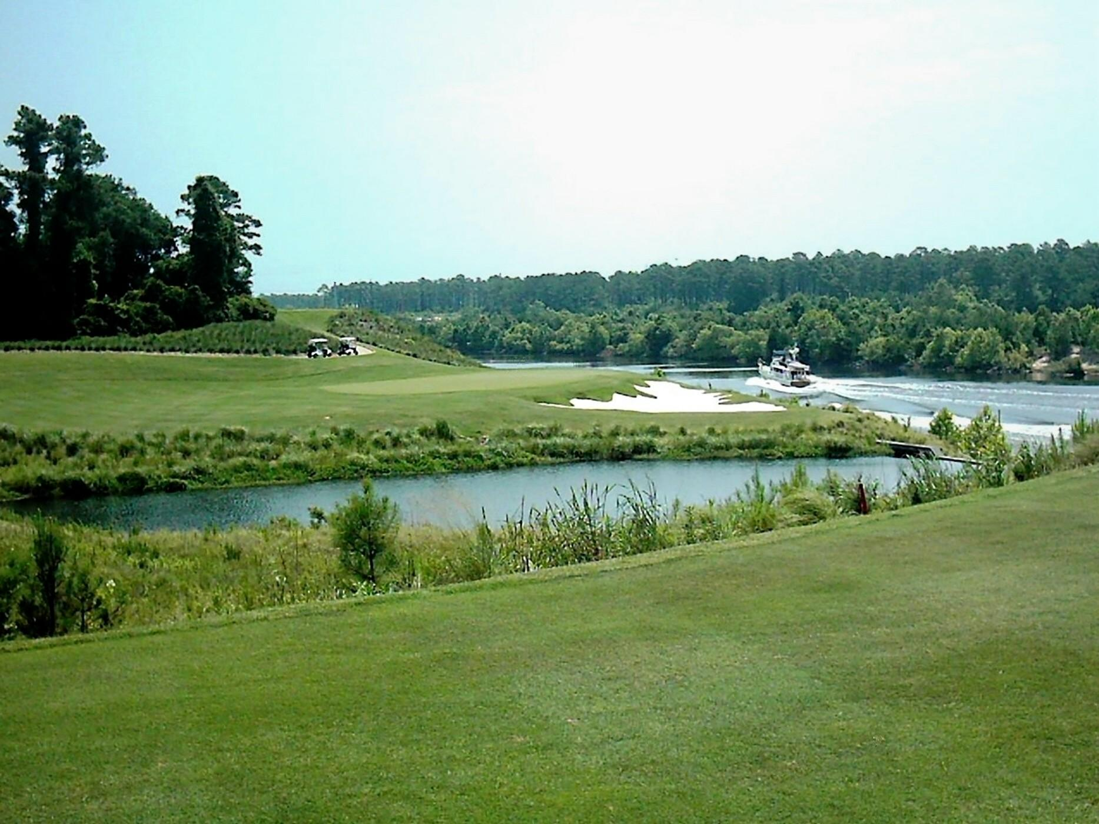

- Grande Dunes Members Club

One of the reasons that we are staying at the Marina Inn at Grande Dunes is to have access to the exclusive Members Club at Grande Dunes which is a private club that may be played by guests staying at the Inn. The Members Course is design collaboration between PGA Hall of Fame inductee, Nick Price, and golf architect, Craig Schreiner. This creative layout weaves throughout the area's natural pine preserves and along the Intracoastal Waterway, presenting a unique variety of shot-making challenges on a gently rolling terrain. This fabulous course is complemented by an elegant 27,000 square foot Italian-designed clubhouse overlooking the lake between the 9th and 18th greens.
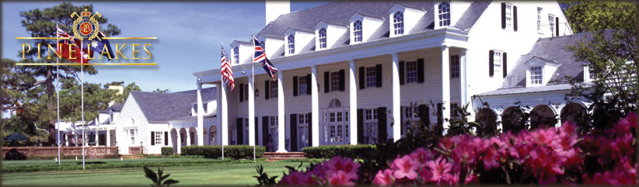
Since 1927, Pine Lakes Country Club has been a favorite of Grand Strand golfers. Nestled in the heart of Myrtle Beach, the graceful Southern architecture of the Clubhouse symbolizes the deeply rooted history and tradition of the Myrtle Beach area.
Pine Lakes was originally built upon natural dunes less than a half mile from the ocean and featured numerous freshwater lakes and rolling fairways. Designed by architect Robert White, the first president of the Professional Golf Association (PGA) of America and a co-founder of the American Society of Golf Course Architects, Pine Lakes has surpassed its initial glory after a complete restoration.
After an extensive renovation to the course and clubhouse in 2008, you can now experience the Granddaddy as it was in the spirit of the 1920s. The back nine reflects White’s original design and the front nine was renovated to enhance the elegant experience golfers from around the world associate with Pine Lakes Country Club. Pine Lakes is currently on the National Register of Historical Places.
For the new era of Pine Lakes, Craig Schreiner was contracted to redesign the course. His passion for the game and its architecture is a natural fit in maintaining the historical integrity associated with Robert White’s original design.
Highlights of the new Pine Lakes:
- Maintained the Scottish theme in the golf course architecture and operations
- Corridors of 16 former holes remained unchanged with two new holes built on north end of property to accommodate a new entrance
- The corridors of the nine holes constructed in the 1920’s stayed almost entirely in tact (new holes 10-18)
- Bunker sand will be mined from the site, similar to the process for Scottish links courses
http://www.pinelakes.com/scorecard.html

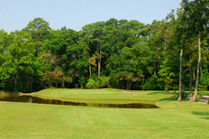



http://www.tidewatergolf.com/Default.aspx
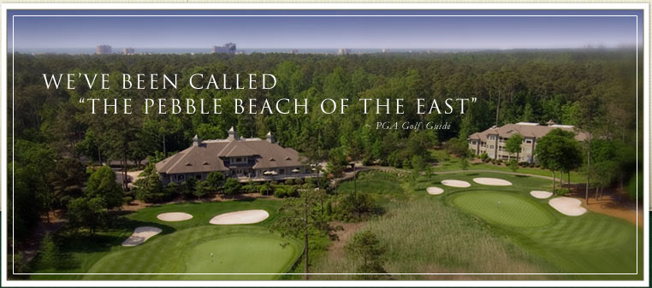

Nestled like a sleeping giant between the Intracoastal Waterway and Cherry Grove, the legendary Tidewater Golf Club offers the perfect combination of natural beauty and challenging play. Seamlessly marrying the game to its surroundings, architect Ken Tomlinson evokes the style and majesty of some of the game’s greatest venues and delivers an experience that puts this course on the must-play list of many Grand Strand golfers. When creating the design for Tidewater, Tomlinson visited some of the game’s greatest courses. Inspired by such legendary venues as Merion and Pine Valley, and respecting the time-honored tradition of crafting a layout that harmonizes with the landscape, he steadfastly refused to incorporate artificial elements and delivered a golf experience that can only come from this special place.

Tidewater sits high atop a peninsula overlooking the Atlantic Ocean. A magnificent saltwater marsh and ocean inlet adjoin the course on the east while the Intracoastal Waterway flanks several holes on the north and west. Adding to the visual variety, thick stands of hardwoods conjure memories of New England’s finest clubs. Flowing with the natural contours of the land, the course challenges you with a range of elevation changes not often found in seaside South Carolina. And as your round progresses, views of the Waterway, marsh and ocean bring fresh inspiration at every turn. With its classic yet contemporary design, the course offers thrilling rewards to shot makers who take chances, use proper course management, and welcome challenges.

http://www.tidewatergolf.com/gallery.aspx
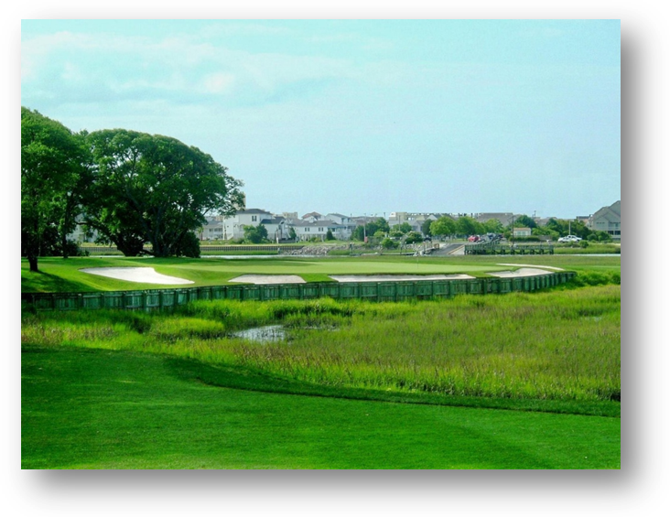
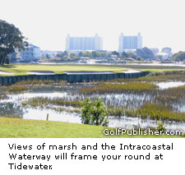
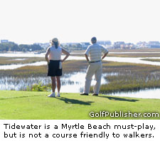

Many observers claim that Robt Trent Jones is the one who did the layout, the routing and the clearing plan. The problem is there were some murky maneuverings going on behind the scenes. Jones contract was never signed, and so his name doesn't appear in connection with the course. It's generally acknowledged Tomlinson did design the greens and most of the bunkers. Most of the regulars who play the course credit Jones with the design.
"You come out and take one look at this course and you know no amateur is going to come in here and design a course like this in a swamp," said Stuart Nickerson, who lives on the course and plays it nearly every day. "It's one of the best. You never get tired of playing it. Nothing compares except the Dunes Club."
Whatever designed the layout, it works. The Grand Strand is home to more than 100 courses, dozens of them excellent, so good that only a few stand out. Tidewater is one of them. Laid out along the Intracoastal Waterway, the layout will dazzle you with scenery and shots. It's a gorgeous course, with overhanging oaks, marsh everywhere and high bluffs overlooking the sun-sparkled Intracoastal Waterway, complete with cruising sailboats and dotted with local fishermen. Everywhere you look, the conditioning is top-notch, even in the autumn when many other Strand courses are suffering.
It's a little longer than 7,000 yards, but you'll feel like you traveled much further than that when you walk off No. 18. The course dips and rises, twists and bends, and nearly every hole has some feature that makes it stand out. Pick your tees wisely: the slope rating is 144 from the back tees and 139 from the gold.
There are numerous holes to highlight: No. 3 was voted "Best par 3 on the Grand Strand," by the Sun News, a short one-shotter with four big bunkers, a sloped, slanting green dropping off to the marsh bordering the waterway. It's a beautiful hole, with wide vistas.
No. 12 has an intimidating peninsula green, with water everywhere, and a bunker all the way across the front and right. The big green slopes sharply toward water.
You can see the ocean from the 13th green, and the 457-yard No. 14 is another pretty layout, a visually deceptive hole that looks longer from the tee than it is. Then there's the 210-yard, par 3 17th - uphill.
And of course, No. 18 may be the toughest on the Strand, a 450-yard dogleg left in which you must reach the dogleg or you're screwed. Even then, your approach must still carry the marsh that cuts across the fairway, to a deep, sloping green. It's long, tricky and unforgiving, with marsh to the right.
Tidewater is a must-play if you want to play the best of Myrtle Beach. Most everyone familiar with the Grand Strand scene puts it in the top two or three. It's scenic and very challenging, to the point it can overwhelm you if you try to play beyond your ability. Women may not find the course enjoyable, with all the forced caries.
It's a nationally recognized course. It was rated the best new course in America in 1990 by Golf Digest, and one of the top 10 new courses by Golf Magazine. The only drawback is that it is set amidst golf communities and you have long treks between holes; it is not walker-friendly. Still, most of the houses are hidden by trees, and you rarely see other golfers. There is a nice feeling of isolation

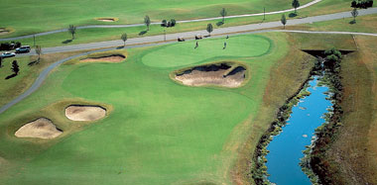
Taking its place alongside the award-winning Heathland and Moorland courses which we played (and loved) last year, Parkland has established itself as the most exciting new course in Myrtle Beach. Offering distinct contrasts to the first two Legends courses, Parkland demonstrates the diversity and beauty of the natural terrain with contoured, tree-lined fairways, vast natural areas, deep-faced bunkers and massive, multi-level greens. Parkland is modeled after the style of architects Alister MacKenzie, (Augusta National) and George Thomas (Riviera Country Club). Playing the unforgettably challenging fairway and green-side bunkering requires a deft touch off the tee and on the approach. From tee to green, strategy will be the order of the day on this stunning, par-72 playing field.

Use this link for a video tour of the Legends courses: http://www.cyberlinksgolf.com/legends%20golf%20resort.html



Meadowlands is our warm up course, being our first round early in the morning on Saturday. Meadowlands was named one of the "Top Ten Best New Courses" by North Carolina Magazine when it opened, Meadowlands Golf Club also earned a spot on Golf For Women's Top 100 Women-Friendly Courses. Designed by Willard Byrd, Meadowlands is located less than one mile from its sister course, Farmstead Golf Links. Which we will play Saturday afternoon.
Meadowlands features a number of unforgettable holes, bordered by serene meadows, mature hardwoods, and vast wetlands. The course's 7,054 yards are artfully sculpted around pristine fresh water lakes and natural vegetation.
One of the most memorable holes is Meadowlands' 432-yard, par 4, 6th hole. From the elevated fairway and the pond that meanders down the left side of the hole, to the hidden water hazard that protects a raised green complex, the 6th hole demands precision golf while distracting the golfer with its stunning beauty.




Test your game with a memorable round at Farmstead Golf Links, home of the Grand Strand’s only par 6 hole. The hole begins in South Carolina where golfers tee off to a wide sweeping fairway, then curves around a lake before ending on a massive green across the border in North Carolina. Stretching out 7242 yards from the back tees, Farmstead offers stunning visual beauty and majestic water hazards. Seven hundred and Seventy six yards. Par 6. At first, he think it's a joke or a misprint. Then he sees his buddies chuckling among themselves. That's right, a 767-yard par 6, 712 from the blue tees. Even if you play from the white tees, it's 679 yards. The ladies have 664 yards to take that long journey. No. 18 may or may not be a gimmick, but whatever it is, it almost always has the same reaction from newcomers. "Wow," Assistant Professional Jason Monahan said. "That's what they say. The statements they make range from, 'I've never heard of a par 6, I've never played a par 6' or 'I can't wait to play a par 6.' A lot of folks who read up on us know it's there, and that's why they come."
It's a classic case of 'if you build it they will come,' and it works. And usually, they come back for the rest of the course. "Once they get out here, between the overall layout, the conditions and the laid-back staff," they come back," Monahan said. "We receive an awful lot of repeat business."
Farmstead advertises itself as a links course, and it comes closer to most that make that promise. It's wide open and rolling, there are few tree-lined fairways, and when conditions are right, or ripe, the fairways are fast and firm, giving you extra roll, unlike so many other soggy courses on the Grand Strand. The funny thing is, No. 18 isn't the hardest hole on the course, by a long shot. In fact, it carries only the eighth handicap. Regulars love it, rejecting the idea of it being a gimmick.
"No, not at all," said Richards. "It's a legitimate par 6. The only time it's hard is when you try to play it like a par 5."
No. 1, a 420-yard par 4 is more difficult, as is the 453-yard 16th, a visually intimidating hole that's a sharp, dogleg right with a fairway banked on the left, sloping briskly down to a waste area right. Farmstead has a number of interesting - and harder - holes that are playable and fun, and that's what brings them back. Play to the 150-yard markers and you'll have your share of birdie putts.
The course has a very natural feel, not all pumped up, as it travels through two states: there's a little, stone marker pointing out the state boundary, so beware, once you get into South Carolina, no beer cart girl. They can't sell beverages in a different state.
With no obstructions, the wind can really howl and make a three- or even four-club difference, tough on the holes that play slightly uphill. There is water on the course, but perhaps a bigger obstacle is the homeowner along the fifth fairway with the electrified fence and three German Shepherds. That's not counting the snakes or fire ants.

The Cost: The cost for lodging (four players in a 3 BR condo with living room and kitchen), (4 nights) all green fees, carts (for seven rounds) and taxes is $899 per person. (Mini-van, air, meals and caddie tip at Grande Dunes members club not included.)
Please RSVP no later than November 30, 2009. E-mail me if you have any questions.

